Middlesex County Netball Association
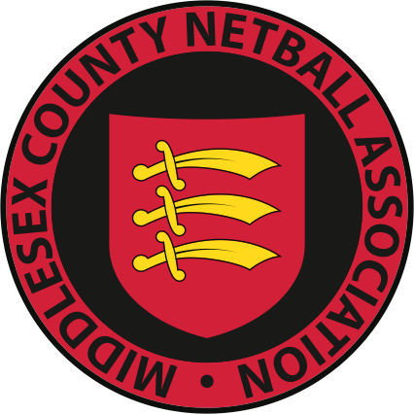
www.middlesexnetball.co.uk
AGM – 24th June 2021
Netball Development Officer Report
Ellis Neal (ellis.neal@englandnetball.co.uk)

England Netball General Update

Following the post-Christmas lockdown, the Government have prioritised opening sport and physical activity to support the rebuild of the physical and mental health of the nation. From March 29th, netball was able restart once again. Since then, many clubs and leagues have worked so hard to get up and running again so that England Netball members could get back to training and some friendly competition. England Netball provided in depth guides, templates, and resources to support the restart of netball. Now, we have an amazing number of netballers back on court and it is a massive well done to the netball family! The Virtual Netball Club (VNC) is still available to members with great content being added weekly, such as the huddle, coaches’ corner, netball through menopause and much more. We also had the opportunity to thank our fantastic volunteers through Volunteers Week. After sitting empty for much of the past year, our nation's netball courts are full of activity again thanks to a brilliant network of volunteers. From local league to Vitality Netball Superleague, our 2,500+ clubs, several hundred leagues, 53 counties and nine regions would not be able to run without volunteers. Also, coaching courses have been updated and some of the content is now delivered virtually, making them more accessible to our members. New courses and the dates of theses should be released soon, so please keep an eye on your member emails.
CAPs Clubs

CAPs is England Netball’s Club Action Planning Scheme, which recognises clubs with U18s that are following and meeting minimum standards. Clubs achieving this accreditation are recognised nationally as being a well-run club.

This year 3 clubs are currently working towards their CAPS. If any clubs CAPS have expired and they are looking to re accredited then please register and I can support you in getting the process going again.

Restart of Programmes:

In May NDO’s & NDCC’s began the process of restarting our community programmes, our main objective is to reengage participants back into the sport. Middlesex with 1 NDO and 2 Netball Development Community Coaches (NDCC) working in 16 London boroughs alongside our casual coaches and partners who deliver our programmes. Many sessions have been re-introduced and we are working hard to ensure everyone is getting the opportunity to play again, and support coaches and venues to ensure this is all done within Covid regulations. We currently have 16 programmes back up and running within the County, and we are working hard to generate more for the summer!

If you have any questions or would like any further information about the work completed or want to develop an area of netball in the County further, then please contact me on ellis.neal@englandnetball.co.uk or 07738696857.
Here is to a great year of netball in Middlesex.

Ellis.

