Middlesex County Netball Association
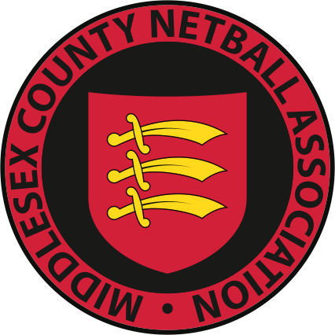
www.middlesexnetball.co.uk
AGM – 24th June 2021
Equality, Diversity and Inclusion Report
Melissa Wright (melissa@middlesexnetball.co.uk)

The Equality, Diversity and Inclusion working group (WG) was formed to promote and encourage inclusivity within our sport. Middlesex are proud to be the first county nationally to have taken on this initiative. I would like to take this opportunity to thank our members for their contributions throughout the year. Adeva Bryan, Alison Akinrinlola, Ava Kean, Elaine Smith-Modu, Julia Mark, Kandis Nelson, Maria Mitchell, Ruth Shields, Tiphany Roberts, and Zoey Dowell. I would also like to thank Katrina May-Kwan (regional diversity lead) for her assistance.

Middlesex Forum
In June 2020 Middlesex held a forum so our members could share their experiences. 45 members attended, and of those 10 volunteered to join our WG. In line with the England Netball Here to Listen forum, the common themes of discussion were policies and procedures, education/training, and umpiring.

Policies and Procedures
Middlesex’s policies and procedures were reviewed by the WG whom provided constructive suggestions and feedback to England Netball. EN have now partnered with Vercida Consulting whose goal is to boost their diversity intelligence by hosting Here to Listen forums, leading training workshops and creating resources for the wider netball family. As soon as the updated policies are available to counties, they will be uploaded to a dedicated page on the MCNA website.

Education/Training
The WG and MCNA agreed that diversity training is an important next step for our county. In October 2020, 40 members of the MCNA Committee, TSGs, and league committees within Middlesex were the first to participate in a series of interactive webinars. These covered topics including diversity, equality, inclusion, racism, and unconscious bias. We hope to roll training out to umpires, coaches, and players soon.

Club and League Diversity Officers
Next season it is a requirement for Middlesex member leagues to appoint a Diversity Officer to their respective committees. It is also now a condition for clubs competing in both the MCNL and WLJNL to appoint a Diversity Officer to their committees. The NLNL are also planning to implement this. The Diversity Officer will be the point of contact for club members, leagues, The Diversity WG, and an advocate for positive change within our sport.

Data Collection
We would like to encourage members to complete the diversity monitoring section when renewing their membership on ENgage this season. This will help us to build a comprehensive demographic of the county, tailor projects to support a specific requirement and report on measurable outcomes.

