## Game Management

**What is Effective Game Management?**

Game Management and Protocols, along with Position and Timing and Vision, form the three main techniques of umpiring netball. The term brings together actions that may be taken by Umpires (including Cautioning a player, issuing an Official Warning, Suspending a player and Ordering a player off); managing Foul Play (which encompasses unfair play, dangerous play and misconduct); and the discipline of Team Officials and bench players.

The Rules Book now provides a defined structure of actions for Foul Play which set out clear guidelines for Coaches, Players and Umpires. Good sportsmanship and player safety are foremost in the changes that have been made.

It is now clearly stated that during a match, the Umpires are the sole judges of fact and of the rules. Umpires are required to take action if the Foul Play Rule is breached and they should not be afraid to apply these rules should a situation occur. Umpires should not allow the players to get away with any Game Management infringements – the norm should be prompt action rather than delayed action.

If used effectively, the application of the Game Management rules should allow a player to understand that they need to adapt to your rulings or that they are approaching the end of your tolerance for a particular action or actions.

While the Rules Book makes Game Management appear black and white, an Umpire that officiates with empathy and an understanding of play will manage situations far better. In many instances, there are lots of things an Umpire can do before going to the disciplinary measures detailed in Rule 13.

**Control and Discipline**

The Game Management section of the Rules Book has been updated with the latest International Netball Federation (INF) update and now provides a clearer structure for Umpires to use and to help players and coaches to understand the likely consequences of certain behaviours.

**Normal sanctions should be applied, however the following actions may also be utilised where appropriate:**

* Quiet Word
* Caution a player
* Issue an Official Warning to a player
* Suspend a player for 2 minutes (match play)
* Order a player off

At any time an umpire may also ask a Captain/s to speak to her player/s regarding a specific required change in behaviour. The umpire must allow there to be adequate time for the message to be delivered to the player/s.

Actions that are contrary to the letter and spirit of the rules of the game or which do not meet accepted standards of good sportsmanship have been defined under Rule 13.2: Foul Play.

Each element of Foul Play has a clear description of what is not acceptable and the sanctions and actions that the Umpire is to apply.

Rule 13.3 provides details of what is expected in terms of discipline from Team Officials and bench players and the sanctions and actions that will be applied by the Umpire.

|  |  |  |  |  |
| --- | --- | --- | --- | --- |
|  |  | Sanction | And | Action |
| Unfair Play | Delaying Play | Penalty Pass | + | Advance the penalty and Caution |
| Intentional infringing | Penalty Pass | + | Caution  Progress to Official Warning and Suspension if player continues to infringe |
| Infringements when the ball is not in play | Free pass (minor infringement)  Penalty Pass (Major infringement) | + | If appropriate - Caution |
| Persistent infringing | Penalty Pass | + | Caution  Progress to Official Warning and Suspension if player continues to infringe |
| Intimidation | Penalty Pass | + | Caution |
| Retaliation | Penalty Pass | + | Caution  If considered serious, Official Warning or Suspension |
|  |  | |  |  |
| Dangerous  Play | Accidental Action | Penalty Pass | + | Official Warning or Suspension |
| Deliberate Action | Penalty Pass | + | Suspension  In a serious case, Ordering off |
|  |  | |  |  |
| Misconduct | Dissent with an Umpire | Penalty Pass | + | Caution or Official Warning In serious case, Suspension |
| Actions contrary to good sportsmanship | Penalty Pass | + | Official Warning or Suspension In serious case, Ordering off |
| Continued Misconduct |  |  | Ordering off |

Rule 13.3 provides details of what is expected in terms of discipline from Team Officials and bench players and the sanctions and actions that will be applied by the Umpire. In a game where contest may be tight and teams are competing hard for a win, an Umpire needs to be confident and alert at all times. If an issue or incident occurs, they should have a number of techniques to keep the match under control.

**Managing the Players and the Team Benches**

• Umpires need to develop a clear and consistent communication style which, for the players on court, must include the use of the recommended Umpire hand signals and terminology

• Use a firm, but friendly, tone of voice

• Develop and maintain an empathy with the Players and the Team Officials

• Umpires should carry out player checks and the toss early and select the match and spare balls in good time

**Working with the Technical Officials**

• Communicate clearly and effectively using an appropriate tone of voice

• Before the start of the game:

»» Agree the positioning of the Team Benches, the Official Bench and the discipline chair

»» Agree the sound that will be used to notify the Umpires of time for the end of each quarter (Usually a horn or bell)

**Steps of Game Management**

**Discipline Ladder**

The varying techniques and strategies for game management can be illustrated in this ladder.

**Step 1 Game Management Techniques**

**These may include:**

• Change in whistle tone/volume

• Change in voice tone/volume

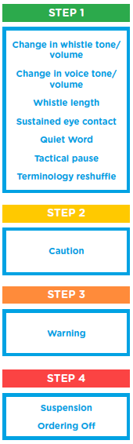• Whistle length

• Sustained eye contact

• Tactical pause

• Terminology reshuffle (state playing position first)

• Quiet Words (specific informal advice eg Tidy up contact)

**Some examples of when these techniques could be used include, but are not limited to:**

• Early signs of a potential persistent infringement building by a player

• Incorrect position of a penalty where this is not considered to be deliberate

• Accidentally delaying play e.g. fumbling of the ball whilst returning for the centre pass

• For infringements when the ball is not in play

• Inappropriate language from a player directed at themselves

• Less skilled players in the match may be clumsy

• Player loses temper with themselves momentarily

**Whistle**

One of the most important tools an Umpire has is their whistle.

Varying the tone and volume of your whistle can often let a player know they are reaching the end of your tolerance for a particular action/s or behaviour.

Varying the length of your whistle will immediately draw the attention of all participants to an action. A sharp and quick whistle will make you appear decisive and confident in your decision making.

Having a whistle with a pea is invaluable. Pea-less whistles are harder to change the volume and tone and even harder to roll for the beginning and end of play. A whistle with a pea will cut through the noise of a crowd and will appear more sharp and crisp to players and spectators alike.

**Voice**

When delivering any terminology, a voice that is calm, non-confrontational but firm is key. Confidence in your decision making will serve to reinforce to players that you are making sound judgements. If your voice is quiet and indecisive, players can often lose confidence. If you do not believe what you are blowing, how will anybody else?

A change in voice tone or volume can also make players aware that you will not tolerate a particular action. Changing the tone of your voice or the order you deliver the terminology sequence or using pauses can make all the difference. For example. ‘Wing Defence (pause), Contact. Penalty Pass’. By saying the playing position first (i.e. reshuffling your terminology sequence), you immediately get the attention of the player. Wait for them to turn and look at you before delivering the rest of your terminology. However, when umpires are in training they should follow the correct terminology sequence.

It should be noted that you will often hear Umpires at international matches or on the television not delivering their full terminology – do not copy them! When you are working your way up through the awards you will need to tick all of the boxes that assessors are looking for.

**Body Language**

The use of a soft arm gesture with the hand out and palm extended can communicate ‘stop that now thank you’ to a player. Sustained eye contact can hold a player’s attention for longer which will reinforce your control and decisions.

**The ‘Quiet Word’**

The use of the ‘Quiet Word’ can help players to adapt quicker to your decisions and adjust their play. This will be done in most instances without the need to hold time. Use short and clear phrases and be specific for example “tidy up your Contact”, “get the right distance”, “stay out of the circle”, “wait for the whistle” (for Breaking at the centre pass).

Try and avoid phrases like ‘no more Contact’ or ‘stop Breaking’ as they could be misinterpreted by players and coaches as a caution.

**Step 2 Game Management Techniques;**

**Caution**

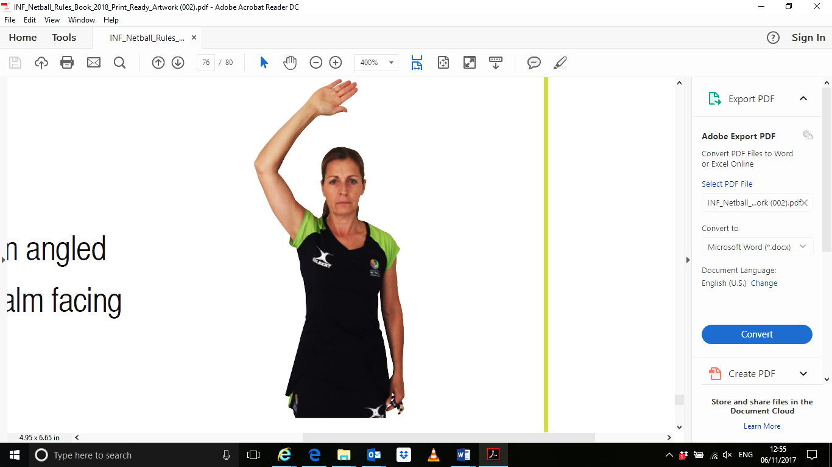The 2016 Rules update introduced the ability for an Umpire to Caution a player. This is to be used in addition to the normal sanction to advise a player that a particular behaviour must change.

There is clear guidance within the Rules Book and Match Protocols about which infringements require an immediate Caution to be given in conjunction with the normal sanction.

When giving a Caution the Match Protocols emphasise the need to hold time to speak to a player which adds a degree of seriousness with the aim being to make the sanction more effective. It allows an Umpire to take a breath and gain composure before delivering their terminology sequence and also it draws the attention of the coaches and other players to the action so they know that it won’t be tolerated by the Umpires.

The ‘Caution’ is not binding on the Co-Umpire. If more than one player from the same team is involved, it may be useful to request the Captain to speak to the players concerned.

How many times should I penalise before giving a caution?

There is no specific number. Good game management is about helping players to adjust their play so that they do not keep breaking the foul play rule. Repeated and persistent violation of the foul play rule should be penalised. Remember, you can start by penalising with the normal sanction and then progress to a quiet word before giving a caution. An umpire must judge when the behaviour is becoming unacceptable and then a caution may be given.

**Action to be taken by the Umpire when Cautioning a player:**

• Remain calm and non-confrontational but firm

• Signal to the timekeepers to hold time using the Hold Time Signal

• At the same time as you blow the whistle to hold time, remember where the ball was and who had possession

• Advise the player what rule they were infringing

For example: “(Player position) you were intentionally obstructing. As a result I am issuing you with a Caution”. No further dialogue should be required

• The umpire will use the Caution hand signal (Elbow bent, arm angled across head, palm facing towards player).

• Set the sanction in the position where the ball was when the match was stopped

• Indicate to the timekeepers you are ready to restart the game

• Blow the whistle and use the restart of play hand signal

A player can receive more than one Caution within a game for different infringements of the Foul Play Rule but umpires should be mindful that a player that receives a second Caution for a different offence may well be persistently infringing and further intervention is required.

**Step 3 Game Management Techniques:**

**Warning a Player**

For a player who continues to infringe after earlier penalties or receiving a Caution or if the actions of the player(s) warrants it, the Umpire will issue an Official Warning to the player(s) concerned.

It is advisable to only use the words ‘Official Warning’ when you are going to issue one. Players, coaches and spectators can become confused if you say things like ‘if you do that again, you’ll get a warning’ or ‘player you are getting close to a warning’. Keep your dialogue short and to the point and always ensure you use the Official Warning hand signal. Umpires should be reminded that Officials Warnings are binding on their co-umpire.

**Action to be taken by the Umpire when issuing an Official Warning to a player:**

• Remain calm and non-confrontational but firm

• Signal to the timekeepers to hold time using the Hold Time Signal

• At the same time as you blow the whistle to hold time remember where the ball was and who had possession

• Ask the player to come to you; you remain off court

• Advise the player what they were doing wrong

“(Player position) you are persistently Contacting

As a result I am issuing you with an Official

Warning”. No further dialogue should be required

• Set the sanction in the position where the ball was when the match was stopped

• Use the Official Warning hand signal to indicate to the

Official Bench, Co-Umpire, Team Bench and spectators that an

Official Warning has been issued

• Indicate to the timekeepers you are ready to restart the game

• Blow the whistle and use the restart of play hand signal

**Step 4 Game Management Techniques**

**Suspending a Player**

Except in extreme circumstances, this will not be done unless an appropriate Official

Warning has been given. The continuation of an action that triggered a previous Official

Warning may warrant a suspension being issued or if serious enough a one off incident may trigger a Suspension. For example: deliberate dangerous play.

The Rules Book now specifies that a player who is Suspended takes no part in play for 2 minutes.

**Action to be taken by the Umpire when suspending a player:**

• Remain calm and non-confrontational but firm

• Signal to the time keepers to hold time using the Hold Time Signal and remember where the ball was and who had possession

• Ask the player to come to you; you remain off court

• Issuing the Official Warning to the player. “(player position), you have already received an Official Warning for (state the infringement), and I am now going to suspend you for two minutes. Report to the Official Bench”. No further dialogue is required

• If a suspension is to be issued for an extreme incident you will only need to state what that incident was followed by the length of the Suspension (2 minutes)

• Use the Suspension hand signal to indicate to the Official

Bench, Co-Umpire, Team Bench and spectators that the player has been suspended

• The suspended player must immediately leave the court and should sit in the chair next to the reserve Umpire or (if in a local league situation) somewhere away from their Team Bench

• Set the sanction in the position where the ball was when the match was stopped

• Indicate to the timekeepers you are ready to restart the match

• Blow the whistle and use the restart of play hand signal

The suspension period of 2 minutes begins when play recommences. It is 2 minutes of playing time.

No substitution is permitted and the suspended player’s position is left vacant unless the player is the Centre when an on court player must move to the Centre position before the match is restarted.

At the end of the suspension period the player **must** return to the original playing position at the next break in play (after a goal has been scored, during a stoppage or interval, when a sanction is awarded, a throw in or toss up taken).

If the suspended player was the Centre, then the Umpire will hold time to allow for the Suspended Centre to return to the Centre position and the player that moved to return to their original position.

A suspended player may join the team during any interval that occurs during the suspension but must return to the Official Bench when play resumes for the remainder of the suspension.

**Ordering a player off**

If an Umpire arrives at the decision to Order a player off, this should be done with confidence and belief that they have done everything within their power to keep the player on the court; or it is as a direct result of a player acting in an extreme manner contrary to accepted standards of good sportsmanship; or of a deliberate dangerous action.

**Action to be taken by the Umpire when Ordering a player off:**

• Remain calm and non-confrontational but firm

• Signal to the time keepers to hold time using the Hold Time Signal and remember where the ball was and who had possession

• Ask the player to come to you; you remain off court

• When Ordering a player off “(player position) you have already been Suspended for (state the reason/infringement), and I am now Ordering you off (hand signal for Ordering off) for the duration of the match. Report to your Team Bench”. No further dialogue needed

• If the Ordering off has been issued for an extreme incident (it would need to be very severe to go straight to ordering off) you will only need to state what that incident was and that the player will take no further part in the match

• Use the Ordering Off hand signal to indicate to the Official Bench, Co-Umpire, Team Bench and spectators that the player has been ordered off

• Set the sanction in the position where the ball was when the match was stopped

• Indicate to the timekeepers you are ready to restart the match

• Blow the whistle and use the hand signal to resume play

The player **must** report to their Team Bench and will take no further part in the match. No substitutions may be made for a player ordered off. The position will be left vacant except if the player was a Centre. One of the on court players must take up the Centre position and the position of this player will remain vacant for the remainder of the match.

**Advancing a Sanction**

Delaying play is now the only time when a sanction can be advanced (unless the non-offending team is disadvantaged) and the sanction is a Penalty Pass. A Caution will also be given to the player.

**Action to be taken by the Umpire when Advancing a Penalty Pass:**

• Blow the whistle and advise the timekeeper to hold time with the correct hand signal

• Advise the player what they were doing wrong

“(Player position) you were intentionally Delaying Play. As a result I am issuing you with a Caution and Advancing the Penalty Pass”. No further dialogue should be required

• Advance the sanction and indicate verbally and with the appropriate hand signal the position of where the penalty is to be taken

• Indicate to the timekeepers you are ready to restart the match

• Blow the whistle and use the hand signal to resume play

Your voice should be clear so all participants involved know why the Penalty Pass has been Advanced. It is the **actual sanction** you are advancing so it must be set correctly. The player that infringed **must** come to the new position. If they cannot enter the area because it is offside to their playing position they need to stand at the edge of their playing area and take no part in the match until the ball is released.

The sanction should only be advanced a distance of up to half a third. This may be to inside the goal circle if the infringement is in the goal third close to the transverse line. When advancing a sanction from the within the goal third to inside the goal circle the complete advancement should be no further than half of a third.

The Umpire can only advance in their area of control but the Co-Umpire may choose to take on the advancement into their area. If this occurs the complete advancement should be no further than half of a third.

**Top Tips for Effective Game Management**

• Do not go into a match with any preconceived ideas about the discipline of a team or a particular player. Treat every game as a fresh start

• Develop a thick skin. Don’t assume that a player that slams the ball down in frustration is frustrated with you or your decision

• Remain calm and non-confrontational but firm

• Practice your dialogue on the way to your match

• Don’t jump straight to a caution if there is the opportunity to use any of the techniques listed in the Discipline ladder.

**Gary Burgess**

International Netball Umpire

November 2017

Reproduction of this document either in part or full is strictly prohibited. ©Gary Burgess IUA - 2017